HALF MOON BAY PELAGIC
FARALLON ISLANDS INFORMATION SHEET –
Boat: New Captain Pete

2021 Trips

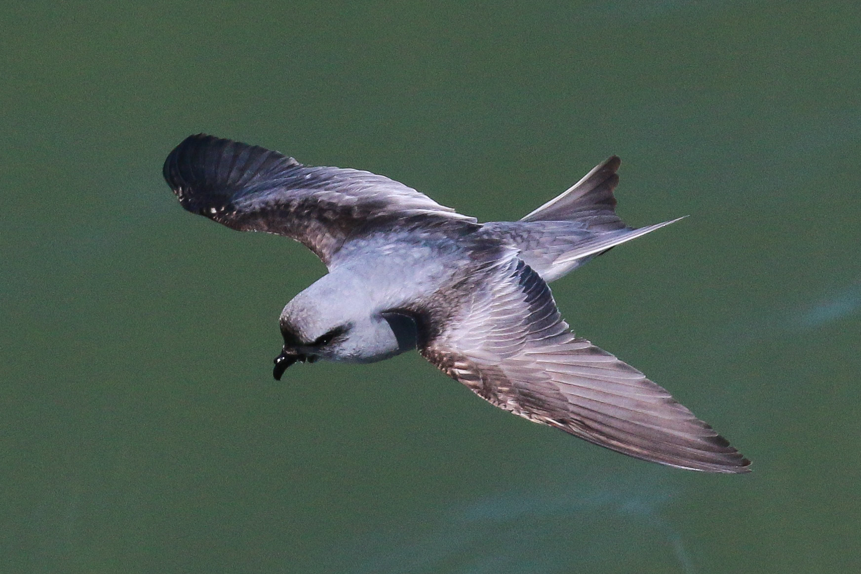
FORK-TAILED STORM PETREL

PROCEDURES DURING COVID-19

We will be adhering to regulations set forth by San Mateo County with regards to charter boat operations. These regulations may be updated as the season progresses. The reduced number of people on board are to facilitate social distancing. Some of the guidance below will be more lenient for vaccinated clients. For more information on procedures, they are detailed in a section at the end of this document.

WHERE AND WHEN

Meet at 6:30 am in front of the Harbor Master’s building at the base of Johnson Pier in Pillar Point Harbor. There are public restrooms right here. We will leave approximately at 7:00 but be here at 6:30 to give yourself a buffer! Our return will be approximately between 4:30 - 5:00 pm, but weather or sea conditions may slow us down, don’t book a flight too close to return times due to this uncertainty.

Our boat is on the last slip on the left in the pier and it (New Captain Pete) is the first in the line. Check in with Alvaro at the base of the pier upon arrival. However, if you arrive late and no one is in front of the Harbor Master’s building, head to the boat (please try to phone me to let me know if you are late). Do not board the boat unless a crew member or one of the guides is there to help.

Please e-mail me with an address and telephone – this is to provide to the harbor and coast guard; it is federal law that we have this information for you. Thanks!

My cell phone is 650-504-7779 just in case.

Note that you will be asked to sign a Liability Waiver before going on the trip, you need sign this only ONCE during the calendar year. I will be including a copy, if you can sign and have at the dock that will make things speedier to get going that morning, I will have a few blank ones as well. Thanks!

DIRECTIONS TO HARBOR
From the South or East Bays, take Highways 101, 280, or 880 to Highway 92 West. Turn right (North) on Highway 1 in Half Moon Bay. Turn left (West) on Capistrano Road (signal light four miles North of Half Moon Bay). Take the first left into Pillar Point Harbor.

From the North Bay, take Highway 1 South seven miles past Pacifica. Turn right (West) on Capistrano Road, and take the first left into Pillar Point Harbor.

Google Map Here
http://goo.gl/maps/nIvlb

PARKING
There is plenty of free parking at the harbor, below is an overhead photo showing arrows where parking is available. However, DO NOT park immediately in front of the shops, this area is designated as 2-hour parking and you will get a ticket if you are there all day. Park behind the shops, in the rows nearer to the Harbor Master’s building, or across the street in the big parking area closer to hwy 1 or in the lot to the west of the parking for the stores/shops/restaurants (see arrows below).

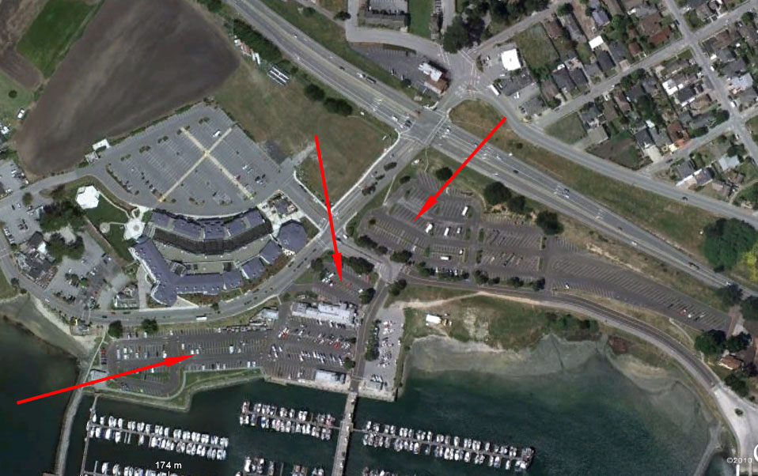
Red arrows = good parking. The white rectangular building below the center arrow are the shops. Avoid the parking area immediately in front of the shops, those are two hours max.

COFFEE OPTIONS

Sit down breakfast is a difficult to find early in the morning in Half Moon Bay. However, the fishermen and locals frequent “The Press Café” in El Granada just across hwy 1 from the harbor, it opens at 5 am!! That is according to recent information (May 2021)

https://menu.me/ca/el-granada/the-press-coffee-bakery-grilled-cheese-house/

Peet’s Coffee in Half Moon Bay opens at 5 am on weekends, and has pastries and coffee. There is also a Starbuck’s in Half Moon Bay and various other local coffee shops, you would have to look at opening times. In the harbor Ketch Joanne restaurant, seafood is their specialty, is a favorite for dinner and post trip celebration!

OUR BOAT

The boat we will be on today is the New Captain Pete, a 53-foot coast guard certified charter vessel. It is a classic West Coast fishing charter boat – and a fantastic birding boat too! All required safety equipment is present on the boat. Captain Dennis Baxter is amongst the most experienced fishing captains in the central California coast; and he is quickly learning the birds too! He has been taking people fishing and whale watching out of Pillar Point Harbor for years, and knows where to find the bait, and that is where the birds and whales will be as well! Also he is a good humored and very helpful guy who we really enjoy doing pelagics with. The boat has two “heads” or restrooms, but no galley or cooking facilities other than a microwave oven you can use to heat packaged soups etc. Before the trip Captain Dennis will give us a summary of safety features and aspects of the boat.

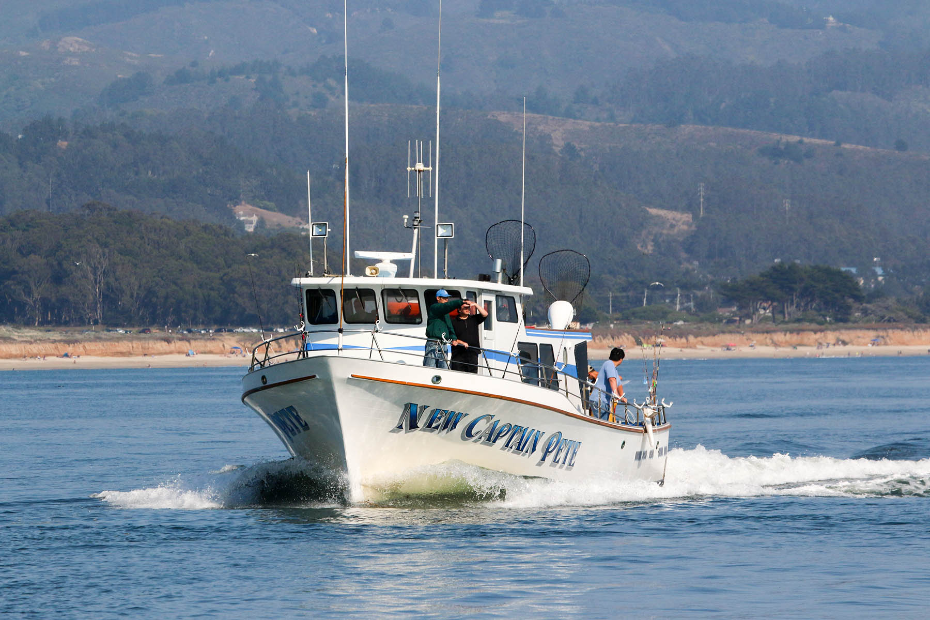

This is the New Captain Pete with Half Moon Bay in the background.

OUR GUIDES – SPOTTERS

All of our guides are volunteers, some may be professional biologists, teachers, tour guides, or just great seabirders but they do this for the experience of getting many hours out on the ocean, and their interest in both seabirds, and showing people seabirds. But to be clear they are not employees, they do this because they find it interesting and fun. As such, keep in mind that they will do all they can to get you on the birds, inform you about the birds, and share the excitement of offshore seabirding but they are not working, they are sharing! I hope very soon to have short write ups on everyone who leads with me, so you can have a better idea of who you are chatting with when on the boat! Do understand that for me I put a great deal of importance in expertise and experience, but I value highly the ability to communicate, and inform about the local birds. Some guides are born educators, others are born rare bird finders, and some are a bit, or a lot, of both. Where possible I also try to involve young people as guides, to foster their interest in birding, the ocean, and particularly so young birders who have an interest in making the natural world their career.

FIELD GUIDE – Birds and Wildlife
Local California birders Steve Howell and Brian Sullivan have written a small and very practical guide to the species we see offshore on our trips. For more information:
https://www.amazon.com/Offshore-Sea-Life-Guide-Princeton/dp/0691166137
http://press.princeton.edu/titles/10465.html

Steve Howell and Kirk Zufelt have just (Aug 2019) published an amazing book for the identification of seabirds throughout the world. Highly recommended:
https://press.princeton.edu/titles/14015.html

Note that Steve Howell and Brian Sullivan are sometimes spotting for our trips, so perhaps you can get your book signed!

CHUMMING
If you have been on pelagics in other parts of the continent or the world, you will know that part of the process of bringing birds close to the boat is to provide fish or squid to “chum in” the birds. Here in Central California, all of the ports (Half Moon Bay, Monterey Bay, Bodega Bay) take you to waters that are part of marine sanctuaries. As such chumming for birds is not permitted in these waters. Chumming in the course of fishing is allowed, but not for birding. Several pelagic tour operators are currently attempting to obtain permits to use chumming as a tool in education and research. This process is ongoing and we are included in this permitting process.

FISHING
Our trips are birding trips, but if pelagic fish such as Albacore Tuna are available, or the right temperature waters are present (Aug to October), we may put out trolling lines to catch a fish. In the past, we have found that going to tuna waters has provided us with great birding, the speed of trolling is good for birding, and the process of bringing in the fish can attract birds. Hawaiian Petrels have come in to the slick created from the capture of Albacore on our trips. Capture of tuna on a trip will be rare, but we may be trying here and there.

TIPPING

Our birding guides do not expect a tip, although if you are a tipper, please go ahead. However, to conduct our operations we are required by law to employ a Coast Guard certified deck hand. The deck hand helps the captain to pilot the vessel, as well as in cleaning, maintenance, keeping the restrooms looking good etc. They are an invaluable part of our trip. In fishing trips deck hands make their earnings largely on tips and filleting fish, on birding trips this does not happen (unless we catch a fish!). To keep birding boats happening, we would love to keep deck hands happy. If you wish to do so, a tip for our deckhand would be greatly appreciated. Little by little we are turning these folks into birders, sometimes they have spotted some good stuff for us too! It is amazing what a life time at sea does to prime you to be a great bird, shark, or whale spotter. We are thankful for the great deck hands we have on our boats.

OUR PLAN

Our aim is to get offshore into waters off the continental shelf. The San Francisco trips will head slightly northwest, or west to get to SF Waters. The San Mateo trips will head west or southwest. The Half Moon Bay Classics will head to offshore waters, but exactly where we go will depend on where most of the bird activity has been recently. Winter trips may spend more time inside or the continental shelf or right at the edge, rather than heading well offshore, as bird distribution at this time of year may be denser inside of the shelf. Weather dictates where we can go, and we realize that the albatross, storm petrels and other goodies tend to be at or beyond the continental shelf so we do our best to get there and look for these birds. Depending our speed, it takes over two hours to reach the deeper waters off the continental shelf. However, weather could preclude us from getting exactly to where we want to be. Knock on wood, it will not happen!

LUNCH

Lunch will not be provided onboard; the boat does have a microwave although most folks pack a sandwich or food that does not need heating. Please pack your own lunch to bring on the boat. Take plenty of water or liquids. Essentially, be prepared to be out all day so have an appropriate amount of food and drink. Keeping your stomach active and working on something is often a good way to avoid seasickness; some folks munch on dry crackers, saltines or ginger snaps throughout the day! I am of the opinion that this helps substantially in keeping you feeling comfortable on a boat.

COMFORT AND SEASICKNESS

Part of what makes this such a rich part of the ocean are the cold water currents and upwelling of cold water offshore. This cold water makes for a generally cool to cold air temperature on a pelagic boat trip. The key is to have layers, that way you can take layers off or put some on depending on the cold or warmth you will experience. Even on a still and relatively warm day, the movement of the boat itself creates enough breeze to drop the effective temperature by a noticeable margin. What can be assured is that it is not going to be hot, and rarely does it ever feel warm. So, avoid shorts, short sleeves and make sure you are prepared for it to be cool to cold. Extra layers you do not need can be left in your pack in the cabin, but you may be happy to have the extra layers if it is a cold day! Better safe than sorry. It seldom rains on us before November, but ocean mist is possible anytime in the summer or fall, so a waterproof layer is always good.
If there is a breeze and we have some spray be prepared to guard your binoculars and or camera against the salt water. Have plastic bags and or dry paper towel to keep your gear from getting wet, and drying it off if need be. You can store gear in the cabin and have it safe from the elements if you need to.
Comfortable footwear is good! You will be standing for a great part of the day, and often balancing as the boat moves, comfortable shoes that are also not slippery are great to have on a boat. Avoid any slippery shoe, even if it is not all that wet, the deck of the boat can get moist and you want to make sure you have a firm grip on the deck at all times. Avoid open toed sandals; first of all because you may get cold, but second of all because in trying to maintain balance you may get stepped on by a fellow birder! It happens, and it can be really painful if you are wearing sandals. But if this is your preferred footwear and are most comfortable wearing them, just be aware of the negatives.
Do not bring a scope, or tripod. These are essentially useless and a bother on a boat. They will channel the boat vibrations right to your scope or camera and the boat movement will make it impossible to use your scope or camera on a tripod. If you will be doing photography, hand holding the camera is the way to go!

Seasickness
If prone to seasickness, look into over the counter medications, and choose the non-drowsy varieties. There is non-drowsy Dramamine, although some folks prefer Bonine. You can also see your doctor to get a prescription Scopace patch, people swear by “the patch” although many complain that they get a dry mouth feeling, so do bring along plenty of fluids. The main prevention is to get lots of rest the night before! The times I have felt seasick coming on have been when I have had too short a night before a boat trip. Also avoid alcohol and spicy food prior to trip. Eat something bland (i.e. toast and milk) so your stomach is not totally empty; keeping something in your stomach goes a long way to minimizing the effects of seasickness. Consider Ginger products: Ginger Snaps, Ginger Ale, Ginger candy, and also soda crackers.
Once on the boat, concentrate on the bird, whales, wildlife and keeping yourself in a “good frame of mind.” If you are prone to seasickness, stay outside in the fresh air; do not head into the cabin more than is necessary. Also look at the horizon as much as you can! Hopefully the sea will provide enough distraction that discomfort will be the last thing on your mind, but if you are prone to it – call your doctor for the patch or get something over the counter.

WEATHER ISSUES
One thing we cannot control is the weather and sea conditions. There are three factors that can affect our trip. One is fog, the other is wind, and the third is sea swell. Sea level fog reduces visibility, although it often occurs when the wind is still and sea conditions are good. Fog will allow us to get to our destination, and often it does not last all day, but it does decrease chance of observations although sometimes less than you would think. Wind can churn up waves and create a wet situation on the boat from sea spray rising off the bow. In days of low wind, it will be drier on the boat. If the wind is high, then this could create wind waves that could keep us from reaching our destination; this depends on the strength of the wind and the direction it is coming from. Swells are the large rounded waves coming off the ocean, often created by distant storms. One can have large swells that are well spaced, and this will be fine. A moderate swell that is closely spaced will create a difficult ride, so we hope for either small swells or distantly spaced swells. We cannot do anything about the weather – but be aware that the sea conditions will dictate whether we can reach deeper waters or whether we even get off the dock. The ultimate decision on what we can do and where we can go will be up to the Captain. But just think good thoughts, and hope the weather will not be an issue at all – most of the times this is the case. If it is raining but sea conditions are good, we will head out so prepare yourself with good rain gear, this may be a consideration only on winter trips, but do keep an eye on the weather.

Weather information is available here:
http://www.ndbc.noaa.gov/data/Forecasts/FZUS56.KMTR.html

The Coastside Fishing Club has various resources:
http://coastsidefishingclub.com/

BIRDS AND MAMMALS
We are eBird friendly, and are happy to share the trip e-bird lists that are submitted by guides on the trip. eBird is a fantastic source for checking on the likelihood of finding certain species, these are the bar charts of occurrence for San Mateo County (where Half Moon Bay is found), as well as San Francisco County as some of our trips bird a great portion of times in their waters. Scroll to the tubenoses, gulls, alcids and phalaropes to get an idea of when birds are present offshore. Much of these data are the birds we report on our trips.

San Mateo County: http://tinyurl.com/m75rq92
San Francisco County: http://tinyurl.com/m2rfcaa

As well, a file will be sent to you with a checklist of the most likely species we could encounter in a summer or fall pelagic trip. Some species are rarer and are bolded to note their higher level of rarity. This is an all-inclusive list for pelagic and Farallon Island trips, and does include some species which are not as likely on a Aug trip as on an October trip (mainly gulls) – so keep that in mind. We will try to see as much as possible, but nature always dictates what is out there for us to find. There are no guarantees that any species will be found, but we will try!!

CANCELLATION POLICIES

Alvaro’s Adventures is a registered California Seller of Travel, CST: 2105497-40, Registration as a seller of travel does not constitute approval by the State of California.

Cancellation due to weather or any other reason is entirely at the discretion of the Captains of each boat. If the weather looks very bad, cancellation may occur the day before and we will make an attempt (phone or e-mail) to contact you and pass on the information. Remember, it is possible that the trip could be cancelled at the dock. There are no guarantees that we will sail until the captain says it is OK. Barring no communication from us, you should show up at the meeting spot and be prepared to sail.
Trips to the Farallons have the aim of getting to the islands. If sea conditions do not allow us to arrive at the islands, no refund will be given. Similarly county trips will try as much as possible to stay in county waters, but sometimes weather and waves dictate what can happen. However, at all times we will make the best, safe effort to achieve the stated goals of each boat trip.
REFUNDS AND CREDITS
The following are our policies concerning refunds:
* If for any reason the trip is cancelled, you will receive a full refund.
* If you cancel 10 days or more before the trip, you will receive a full refund.
* If you cancel less than 10 days before the trip, you will only receive a refund if we are able to fill the trip.
* There is no penalty if you provide your own replacement, provided they are not already signed up for the trip.
* If a trip departs but must return early, and the Captain charges a pro-rated refund to Alvaro’s Adventures, you will receive a partial refund based on the pro-rated amount.
If a trip is cancelled, you may choose to receive a refund or credit for another trip.
Refund checks are normally mailed out within a week of the trip date, if you paid through PayPal, we can refund through their system as well.
COMPANY LIABILITY
We aim to provide a safe a trip as possible. However, it is important to remember that these trips take place on a moving boat on the ocean, with a number of other participants on board. THIS CAN POTENTIALLY BE DANGEROUS!
Alvaro’s Adventures is not responsible for any injuries, broken, lost, or stolen property, seasickness, or any other misfortunes that occur during these trips.
Alvaro’s Adventures makes no guarantees concerning trip destination or species we are attempting to see.
DISCLAIMERS
Alvaro’s Adventures is not responsible for events or situations that are beyond its direct and effective control. Without limitation, the following are some factors that are beyond our direct control; bad weather, traffic, traffic accidents, labor disputes and strikes, participant lateness, road construction, mechanical breakdown of boats, cars etc., civil disorder or failure of third party providers.
Alvaro’s Adventures reserves the right to refuse to provide tour services to any individual or private group without limitation or any civil or financial liability, whatsoever.

COVID-19 PROCEDURES
- Each Passenger must sign the waiver, prior to being permitted access to our boats. The waiver is an online document.
- The number of people aboard the boat will be limited based on available seating for adverse weather conditions and to maintain required social distancing.
- Seating inside the cabin will be restricted to vaccinated clients.
- You will be asked for your vaccination status before the trip.
- Bathrooms (“Heads”) will be constantly monitored, cleaned and sanitized by crew after each use while being checked for adequate soap, sanitizer and paper goods.
- The boat and equipment is always scrubbed with soap and rinsed with bleach solution, and the crew will do so before, between and after each trip. Any and all cleansers are CDC approved for COVID19 protocols, will be clearly marked and properly contained. FV New Captain Pete will utilize a 70% (minimum) isopropyl alcohol solution on the tables and surfaces inside the cabin during the course of the trip. All surfaces will be treated with bleach solution at the CDC recommended ratio after passengers have disembarked.
- Hand sanitizer will be made available throughout the boat and at each rod station. Passengers and crew can wash their hands with running water and soap at the sink in the main cabin and will be encouraged to do so frequently.
- Passengers will not be permitted to bring ice chests, coolers, alcoholic beverages, illegal drugs, firearms or explosives on board the vessel. Passengers may bring a single hand held lunch cooler only.
- Passengers shall not shake hands, share food or drinks, or engage in any unnecessary physical contact. The captain and crew shall instruct passengers on these requirements.
- All employees and passengers are required to wear face coverings.
- Rails, counters, bathroom, and seating areas shall be cleaned as frequently as needed to maintain sanitary conditions.
- Passengers shall disembark one at a time as instructed by the crew or captain.
- Each crew member has received training in sanitation procedures and will be provided all necessary PPE including masks and gloves.
- Crew will notify the Captain immediately if Covid-19, other respiratory illness of flu-like symptoms develops in any passenger or crew member. According to the Center for Disease Control and Prevention ("CDC") the following may appear as symptoms of infection within 2 - 14 days after exposure to the virus: fever, cough, shortness of breath or difficulty breathing, chills, repeated shaking with chills, muscle pain, headache, sore throat and or loss of taste/smell.
- Captain and/or crew will conduct a safety orientation for passengers immediately after the last passenger has boarded. This orientation will include:
  - 6 foot social distancing requirements as indicated by rod holders and taped markers on seating areas.
  - Hand sanitizer is provided at each rod holder, inside each bathroom, and inside the main cabin at the sink.
  - Passengers will be instructed to inform the crew after they have used the bathroom so that it can be sanitized and checked for adequate soap, sanitizer and paper goods after each use.
  - Cabin and deck areas will be also sanitized using CDC approved products prior to the trip, frequently during the trip and after passengers have disembarked.
  - Passengers and crew must wear masks or face coverings at all times and are encouraged to wear gloves as well.
  - Passengers will be requested to inform crew if any illness or flu-like symptoms (described above) develop in themselves or a family member. The captain will then notify the US Coast Guard to take steps to implement responsive measures, if any, as directed by County Health Officials. Such measures may include imposition of physical separation of passengers to the extent possible within the physical confines of the vessel, early trip termination, diversion to nearer port for passenger treatment and/or medical intervention, and other individualized intercession as circumstances warrant.
  - While birding, passengers must maintain recommended social distancing when viewing birds. Even if an unusual species shows up, passengers are to remain 6 feet apart unless they live in the same home or are vaccinated.
  - Non-compliance with these restrictions will result in refusal of service.
5/21 - AJ

